Disentangling within- and between-female egg size–number trade-offs in the European earwig.
Clint D. Kelly^{1,✉}
¹ Département des Sciences biologiques, Université du Québec à Montréal, Montréal, Canada
✉ Correspondence: Clint D. Kelly <kelly.clint@uqam.ca>

Abstract
Life-history theory predicts a trade-off between offspring size and number, yet empirical studies often fail to detect the expected negative association. This discrepancy may arise because phenotypic correlations conflate variation in resource acquisition with variation in allocation strategy. Using repeated measures of female European earwigs (Forficula auricularia), I partitioned covariance between egg size and egg number into among- and within-female components using Bayesian mixed models. The raw phenotypic correlation was near zero. However, females that produced more eggs on average laid smaller eggs, revealing a moderate negative among-female association consistent with an allocation trade-off. In contrast, there was no detectable within-female covariance once clutch order was accounted for. Egg number repeatability was effectively zero, indicating that clutch size varied primarily within rather than among females, whereas egg size was highly repeatable. Both egg number and egg size declined in second clutches, and within-clutch egg-size variance increased, suggesting a reproductive constraint (i.e. fewer functional variables) under diminished resource state. Together, these results show that the size–number trade-off is expressed primarily among females through consistent differences in allocation strategy, while clutch size itself is labile. By disentangling hierarchical sources of variation, this study demonstrates that allocation trade-offs can remain hidden at the phenotypic level and that evolutionary constraints operate through stable allocation rules rather than flexible clutch-size adjustment..

Introduction
Life-history theory predicts that organisms must allocate finite resources among competing fitness components. Because energy and time are limited, investment in one trait constrains investment in others (Stearns 1992; Roff 1992). A central expression of this principle is the offspring size–number trade-off: for a given reproductive budget, producing larger offspring reduces the number that can be produced (Smith and Fretwell 1974; Parker 1982). Since larger eggs often enhance offspring performance and survival (Clutton-Brock 1991), selection is expected to favour an optimal balance between egg size and egg number that maximises maternal fitness. Yet empirical tests of the size–number trade-off often fail to reveal the expected negative relationship. Across individuals within populations, egg size and egg number are often positively correlated (Roff 1992; Bernardo 1996; Fox and Czesak 2000; Hargitai et al. 2005). This apparent contradiction arises because phenotypic correlations conflate two distinct biological processes: variation in resource acquisition and variation in allocation strategy. Van Noordwijk and De Jong (1986) showed that when variance in acquisition exceeds variance in allocation, individuals with greater resource pools can produce both more and larger eggs, generating positive among-individual correlations even if all individuals are constrained by the same underlying allocation trade-off. In such cases, the population-level pattern masks allocation constraints operating within individuals—an outcome conceptually analogous to Simpson’s paradox (Simpson 1951).
From this perspective, the critical prediction of life-history theory is not simply a negative phenotypic correlation, but a negative within-individual covariance between egg size and egg number once among-individual differences in acquisition are accounted for (Careau and Wilson 2017). Detecting such a masked trade-off, therefore, requires partitioning phenotypic variance and covariance into hierarchical components. Repeated measures of individuals allow estimation of (i) among-individual variance, reflecting consistent differences among females in total reproductive investment, and (ii) within-individual variance, reflecting how females adjust allocation across reproductive bouts. Careau and Wilson (2017) argue that only by decomposing covariance into these components using multivariate mixed models can we determine whether allocation trade-offs operate within individuals despite positive population-level associations. Crucially, this framework also predicts that traits involved in allocation trade-offs should show substantial repeatability. If females differ consistently in resource acquisition, egg size and egg number should exhibit among-individual variance across clutches. High repeatability would therefore indicate persistent differences in total reproductive investment among females, consistent with variation in acquisition. At the same time, detecting a negative within-individual covariance would indicate that, conditional on their resource pool, females trade off egg size against egg number across reproductive events. Thus, variance partitioning and repeatability are not merely statistical descriptors, but tests of the underlying acquisition–allocation structure predicted by life-history theory.
Despite the foundational importance of the size–number trade-off, no studies have explicitly applied this framework to test whether positive phenotypic correlations conceal negative within-individual allocation trade-offs. Here, I address this gap using the European earwig, Forficula auriculari, a species that allows repeated measures of reproductive investment within females but whose pattern of allocation to egg number and size is unclear (Koch and Meunier 2014). Female earwigs lay a clutch within a short temporal window in a subterranean burrow (Meunier 2024) and provide extended maternal care (Staerkle and Kölliker 2008; Meunier 2024). In Quebec populations, environmental constraints typically render females effectively semelparous (Tourneur 2018), but under favourable laboratory conditions, they can produce a second clutch. This system, therefore, enables direct estimation of within-female covariance across successive reproductive bouts. I test three predictions derived from acquisition–allocation theory (Van Noordwijk and Jong 1986; see also Reznick et al. 2000). First, if variance in resource acquisition among females exceeds variance in allocation strategy, then egg size and egg number should exhibit substantial repeatability and a positive among-individual correlation, whereas the within-individual correlation should be negative, revealing a masked allocation trade-off. Second, if maternal fitness is maximised at a particular offspring size or number (Smith and Fretwell 1974), then one trait should remain relatively invariant across clutches while the other adjusts between reproductive bouts (Winkler and Wallin 1987). Third, if reproductive investment is structured differently across bouts, then variance in egg size may differ between first and second clutches at both the among-female and within-clutch levels (e.g. Hargitai et al. 2005), providing further insight into how selection shapes the distribution of maternal investment across reproductive events.
By separating among-female differences in total reproductive investment from within-female allocation decisions, this study tests a fundamental question in life-history theory: do apparent positive associations between egg size and number reflect relaxed constraints, or do allocation trade-offs persist but remain hidden within individuals? Demonstrating a negative within-female covariance despite positive population-level patterns would show that acquisition can mask, but not erase, the constraints imposed by finite resources. In this way, my study assesses not only the presence of a trade-off but also the hierarchical structure through which life-history constraints are articulated.

Methods
I collected adult female earwigs (n=42) in September and October 2024 in an urban parks (Parc Outremont) in Montréal, Canada. All earwigs were brought into the laboratory, assigned a unique ID, and individually placed in a 90-mm-diameter Petri dish containing a thin layer of moist sand. Females were provided a cotton-plugged water vial and fed TetraMin Tropical fish flakes ad libitum. Females were maintained in an incubator (Percival) at 10°C in constant darkness.
Females were checked daily for oviposition. When a female laid eggs, I recorded the date and collected all eggs from the sand and placed them on filter paper in a new Petri dish. The eggs were then photographed under a Leica S6D stereo microscope (Leica Microsystems Inc., Concord, ON, Canada) at 0.68x magnification using Enersight software (Leica Microsystems Inc., Concord, ON, Canada), which automatically adds a scale bar to the photo. Eggs were then discarded.
To stimulate females to lay a second clutch of eggs, I recreated a brief period of spring where they were allowed to accumulate resources for egg production and replenish their sperm stores. To achieve this, females that had recently oviposited were placed in a new Petri dish containing a cotton-plugged water vial, TetraMin Tropical fish flakes, and a shelter consisting of four 4 cm-long pieces of paper straw (Blowholes, Markham, Canada) glued together. These Petri dishes were placed in a 23 °C incubator with a 12L:12D light: dark cycle. Females were maintained under these conditions for two weeks, at which time a haphazardly chosen stock male from our colony was placed with her. The pair was kept together for a week, after which a new stock male replaced the original male, and that pair was kept together for another week. Females were then transferred to the 10 °C incubator and treated as previously until they laid their second clutch, at which point their eggs were photographed. Females were euthanised by freezing after laying their second clutch, and their pronotum was photographed as described above. Because female fecundity is often related to body size in insects (Honek 1993) and could thus possibly explain a postive among-female covariance between egg number and size I measured to proxies of size, pronotumlength and body mass. Females were weighed to the nearest 0.01 mg using a Sartorius Secura 224-1S analytical balance. Females were weighed three times, with each weighing bout separated by four days. I used Fiji image analysis software (Schindelin et al. 2012) to measure the length of the female pronotum to the nearest 0.001 mm three times, with each measurement separated by 4 days. I used the same procedure to measure the perimeter of each egg.

Statistical analysis
I calculated the repeatability of the body mass, pronotum length and egg perimeter measurements using the R package rptR (Stoffel et al. 2017). I entered the trait of interest as the response variable, female ID as a random effect, and assumed a Gaussian distribution. Each analysis was based on 1000 bootstrap samples. The measurements of my two morphological traits were highly repeatable (pronotum length: R [95% CI] = 0.98 [0.97, 0.99]; body mass: R [95% CI] = 0.99 [0.988, 0.996]); therefore, I used each female’s mean value for each trait where necessary. Because egg perimeter was highly repeatable in both clutches (first clutch: R [95% CI] = 0.977 [0.976, 0.979]; second clutch: R [95% CI] = 0.93 [0.926, 0.937] ), I calculated each egg’s average perimeter and then used these values to calculate the mean egg size for each clutch for each female.
To reduce the two correlated measures of body size (pronotum length and body mass) to a single structural size metric, I performed a principal components analysis (PCA) on the correlation matrix of standardized variables using the prcomp function in the R stats package (R Core Team 2025). The first principal component (PC1) explained 60.8% of the total variance and was used as an index of structural body size. In addition, female body condition was estimated using the scaled mass index (SMI) following Peig and Green (2009, 2010; see also Kelly et al. 2014), which standardizes body mass relative to structural size (pronotum length).
All subsequent analyses were conducted in a Bayesian framework using the brms package (Bürkner 2017) in R. Models were fitted using Hamiltonian Monte Carlo sampling with four independent chains and 4,000 iterations per chain. Weakly informative priors were specified for all parameters to regularize estimation while remaining minimally restrictive. Convergence was evaluated using the potential scale reduction factor ($\hat{R}≈1.00$), effective sample sizes (bulk and tail ESS), and visual inspection of trace plots. All reported parameters met standard convergence criteria. Unless otherwise noted, parameter estimates are presented as posterior means with 95% credible intervals (CrIs), and effects were considered supported when CrIs did not include zero.
To test whether egg size and egg number differed between first and second clutches, I fitted a multivariate Bayesian mixed-effects model. Mean egg size was modelled assuming a Gaussian error distribution with an identity link, whereas egg number was modelled using a Poisson distribution with a log link. Both traits were modelled jointly to account for covariance at the female level. For each response variable, the model included a fixed intercept and clutch order (first versus second clutch) as a fixed effect. Female identity was included as a random intercept for both egg size and egg number to account for repeated measures across clutches. The female-level random intercepts for the two traits were allowed to covary, thereby estimating the among-female variance–covariance structure between egg size and egg number. Residual correlations were not estimated (set_rescor(FALSE)), such that covariance between traits was modelled exclusively at the female level. This model therefore tested whether egg size and egg number differed systematically between clutches while accounting for repeated measures and among-female variation.
I used two approaches to test the prediction that females will exhibit negative within-female and positive between-female covariance between egg number and size. The raw phenotypic association between egg number and egg size was calculated using Pearson’s correlation coefficient across all observations. This estimate reflects the overall linear association between traits without accounting for repeated measures or hierarchical structure. To estimate among-female covariation, I calculated the Pearson correlation between female mean egg number and female mean egg size, averaging across broods. This approach isolates between-female covariance independent of within-female variation. To formally partition covariance into among-female and within-female components, I fitted a multivariate Gaussian mixed-effects model including egg size and egg number as joint responses. Female identity was included as a random intercept for both traits, and both female-level and residual correlations were estimated (set_rescor(TRUE)). The correlation between female-specific intercepts quantified the among-female association, whereas the residual correlation quantified the within-female (clutch-level) association between egg number and egg size.
To distinguish plastic from strategic effects, I followed van de Pol and Wright (2009) by decomposing egg number into two components. The within-female component represented the deviation of each observation from a female’s own mean egg number, and the between-female component represented each female’s mean egg number relative to the population mean. Although mean-centering has been shown to impose assumptions about biological process (Westneat et al. 2020), these assumptions align with my biological question, which concerns deviations in reproductive allocation within females across clutches. I fitted a linear mixed-effects model with mean egg size as the response variable, including both components as fixed effects and female identity as a random intercept. In this framework, the within-female coefficient estimates the plastic allocation response, whereas the between-female coefficient estimates the among-female (strategic) association. Continuous predictors were standardized by centering them on their mean and scaling by their standard deviation. The within- and between-female components were each standardized using the mean and standard deviation of their respective distributions. When estimating standardized regression coefficients, the response variable was also scaled to have a standard deviation of one. Standardized coefficients therefore represent the expected change in egg size, measured in standard deviation units, associated with a one standard deviation change in the predictor.
To test whether females differed in their propensity to trade off egg size against egg number, I fitted a mixed-effects random-slopes model allowing the within-female effect of egg number to vary among females (see Pol and Wright 2009). Mean egg size was included as the response variable, and egg number was partitioned into within-female and between-female components as described above. The within-female component was included as both a fixed effect and a random slope, while the between-female component was included as a fixed effect. Female identity was included as a random effect with both intercepts and random slopes for the within-female component. This parameterisation estimates among-female variation in within-female slopes and the correlation between intercepts and slopes, thereby quantifying heterogeneity in allocation strategies and testing whether females with larger average egg size differ systematically in the strength or direction of their within-female trade-off.
Because egg number and egg size both changed systematically across clutches, I tested whether clutch order explained the observed within-female association by adding clutch order as an additional fixed effect to the within–between model. In this extended model, mean egg size was predicted by the within-female deviation in egg number, the between-female mean egg number, and clutch order, while female identity was retained as a random intercept. If the within-female slope was reduced toward zero after including clutch order, this would indicate that the apparent within-female association was largely driven by parallel shifts between first and second clutches rather than by plastic allocation within females.
To compare clutch-specific variance components independently of random-slope parameterisation, I fitted a hierarchical Gaussian model in which female effects were estimated separately for first and second clutches. Scaled egg size was modelled as a function of clutch order with clutch-specific random intercepts for female identity. This parameterisation estimated separate among-female variance components for clutch 1 and clutch 2, as well as their correlation, allowing direct comparison of female-level variation across reproductive events. Residual standard deviations were also allowed to differ between clutches. Clutch-specific variance components were derived from posterior samples, and differences between clutches were evaluated using posterior contrasts.
Data were visualized using ggplot (Wickham 2016) and tidybayes (Kay 2020).

Results

Effect of clutch order on egg size and number
Both egg number and egg size declined in the second clutch. In the multivariate Gaussian–Poisson model, egg size was smaller in clutch two ($\overset{‾}{x}$ ± SE = 3.41 ± 0.03) relative to clutch one ($\overset{‾}{x}$ = 3.54 ± 0.03; $β$ = -0.12, 95% CrI (-0.21, -0.04). Egg number also declined significantly (clutch one: $\overset{‾}{x}$ = 51.55 ± 2.49; clutch two: $\overset{‾}{x}$ = 34.14 ± 2.65; log-scale $β$ = -0.41, 95% CrI (-0.48, -0.34), corresponding to an approximate 34% reduction on the natural scale ($e^{-0.410}≈0.66$). Among-female variation remained detectable for both egg size (SD = 0.091, 95% CrI [0.009, 0.165]) and egg number (SD = 0.355, 95% CrI [0.273, 0.460]), indicating persistent heterogeneity across broods.

Multilevel correlations between egg number and egg size
Across all observations, the raw Pearson correlation between egg number and egg size was weak and close to zero ($r_{raw}$ = -0.04, 95% CI [-0.25, 0.19]), suggesting no clear phenotypic association when hierarchical structure was ignored. In contrast, the between-female Pearson correlation calculated from female means was moderate and negative ($r_{between}$ = -0.31, 95% CI [-0.55, -0.02]; Figure 1). Females that produced more eggs on average tended to lay smaller eggs. The multivariate Gaussian model partitioned covariation into among-female and residual components. After accounting for female identity, the residual (within-female) correlation between egg number and egg size was effectively zero and highly uncertain ($r_{within}$ = 0.0066, 95% CI [-0.20, 0.23]; Figure 2). Thus, apparent phenotypic independence masked a moderate negative association among females but no detectable clutch-level trade-off within females. From this model I also calculated egg number repeatability, which was effectively zero (R = 0.0017 [95% CrI: 0.0000, 0.0589]), indicating that most variation occurred within rather than among females. For completeness I also calculated the repeatability of egg size, which was low (R = 0.12 [95% CrI: 0.00, 0.43]), with the proviso that this estimate is based on mean egg size per female; better estimate of egg size repeatability is given below.

Within–between mixed-effects models
In the within–between mixed-effects model, egg size varied among females (random-intercept SD = 0.07, 95% CrI [0.00, 0.15]). The within-female effect of egg number on egg size was small and uncertain ($β_{W}$ = 0.0028, 95% CrI [-0.0005, 0.0061]; Figure 3). On the natural scale, this corresponds to an increase of approximately 0.027 units in egg size for every additional 10 eggs within a female — an effect that was not credibly different from zero. In contrast, the between-female effect was negative ($β_{B}$ = -0.0039, 95% CrI [-0.0076, -0.0001]; Figure 1). Females differing by 10 eggs in mean clutch size differed by approximately 0.038 units in egg size. Although the credible interval extended to zero, the posterior distribution was predominantly negative, consistent with a modest among-female trade-off. No measure of female size/condition was positively correlated with the number of eggs in the first brood (pronotum length: $r$ = 0.14, 95% CI [-0.19, 0.43]; body mass: $r$ = 0.12, 95% CI [-0.21, 0.43]; PC1: $r$ = -0.17, 95% CI [-0.44, 0.15]; scaled mass index: $r_{raw}$ = -0.02, 95% CI [-0.35, 0.33]) suggesting that larger females or those in better condition produce more eggs. I therefore did not inlcude a measure of size/condition in this model.
Standardized coefficients reinforced the difference in magnitude between hierarchical levels. The standardized within-female effect was positive but uncertain ($β_{Wstandardized}$ = 0.17, 95% CrI [-0.03, 0.38]), whereas the standardized between-female effect was negative and its credible interval did not overlap zero ($β_{Bstandardized}$ = -0.23, 95% CrI [-0.455, -0.006]). Thus, the negative association was stronger and more consistent among females than within females.
Because both egg number and egg size declined across clutches, clutch order was included as an additional fixed effect to test whether it explained the weak positive within-female slope. When clutch order was accounted for, the within-female effect collapsed to zero ($β_{W}$ = -0.0004, 95% CrI [-0.0045, 0.0035]). Thus, there was no evidence that females plastically traded egg number against egg size within clutches; the apparent association in the initial model was entirely explained by parallel declines from clutch one to clutch two.
Allowing within-female slopes to vary among females produced similar fixed-effect estimates ($β_{W}$ = 0.0034, 95% CrI [-0.0004, 0.0076]; $β_{B}$ = -0.0041, 95% CrI [-0.0082, -0.0002]; Figure 3). Variation in within-female slopes was small (SD = 0.0046, 95% CrI [0.0003, 0.0110]), and the intercept–slope correlation was highly uncertain (r = 0.20, 95% CrI [-0.67, 0.85]), indicating no strong evidence that females differed substantially in plastic allocation patterns.

Egg size variation between females and within clutches
Egg size exhibited substantial variation at both the between-female and within-clutch levels (Figure 4). Between-female variance was similar across reproductive events, with a median of 0.77 (95% CrI: 0.52, 1.23) in first clutches and 0.64 (95% CrI: 0.42, 1.00) in second clutches. The posterior median difference (second − first) was -0.14 (95% CrI: -0.60, 0.29), and the posterior probability that between-female variance was greater in second clutches was 0.26, indicating no clear evidence of a difference. In contrast, within-clutch (egg-to-egg) variance was substantially higher in second clutches (median = 0.35 (95% CrI: 0.33, 0.38) than in first clutches (median = 0.21 (95% CrI: 0.20, 0.22). The posterior median difference was 0.14 (95% CrI: 0.12, 0.17), with a posterior probability of 1.00, that within-clutch variance was greater in second clutches.
Egg size was highly repeatable in both broods, but repeatability was higher in first broods (R = 0.64 [95% CrI: 0.54, 0.74]) than in second broods (R = 0.79 [95% CrI: 0.71, 0.86]), indicating greater within-female variance in egg size expression during second reproductive attempts.

Discussion
Life-history theory predicts a trade-off between offspring size and number because both traits draw from a finite pool of reproductive resources (Lack 1947; Smith and Fretwell 1974; Stearns 1992; Roff 1992). However, whether this trade-off is detectable depends on the hierarchical scale at which variation is examined. As formalized by van Noordwijk and de Jong (1986; see also Reznick et al. 2000), variation in resource acquisition can mask allocation trade-offs at the phenotypic level. By partitioning covariance into among-female and within-female components, my results show that the size–number trade-off in this population is expressed primarily among females, not within them, and that late reproduction is characterized more by constraint than by adaptive plasticity. Crucially, this pattern emerges against a background of near-zero repeatability in egg number, indicating that clutch size itself is not a stable female attribute in this system.
Across females, mean egg number and mean egg size were moderately and negatively associated. Females that produced more eggs on average laid smaller eggs, and the standardized between-female effect was credibly negative. This pattern is consistent with a classical allocation trade-off (Smith and Fretwell 1974), indicating systematic differences in how females distribute reproductive resources between offspring number and offspring size. Under the van Noordwijk and de Jong (1986) framework, a negative among-individual correlation implies that variation in allocation outweighs variation in acquisition. If acquisition differences dominated, females with greater resources would produce both more and larger eggs, generating a positive or null association. Instead, females align along an allocation axis: some produce relatively many small eggs, whereas others produce fewer large eggs. Importantly, this trade-off was not visible in the raw phenotypic correlation, which was near zero; a finding similar to that of Koch and Meunier (2014). Only after partitioning covariance did the negative among-female relationship emerge, directly illustrating how hierarchical structure can obscure allocation trade-offs when levels of variation are conflated (1986; Stearns 1992).
High repeatability of egg size further supports this interpretation. Substantial among-female variance and repeatability estimates (R ≈ 0.79 in first broods and 0.64 in second broods) indicate persistent differences in mean reproductive phenotype (Lessells and Boag 1987; Dingemanse and Dochtermann 2013). In sharp contrast, egg number repeatability was effectively zero, with credible intervals overlapping zero. Thus, while egg size reflects stable, female-specific allocation strategies, clutch size does not. The among-female trade-off therefore arises because females differ consistently in allocation rule (egg size), whereas egg number appears much more labile and context-dependent. In other words, what is evolutionarily stable among females is how resources are divided per offspring, not how many offspring are produced per reproductive bout.
The near-zero repeatability of egg number has important implications for interpreting the trade-off. Repeatability sets the upper limit to heritability and reflects the proportion of variance attributable to consistent among-individual differences (Lessells and Boag 1987; Falconer and MacKay 1996). In my study, clutch size varied primarily within females rather than among them. This suggests that egg number is strongly influenced by short-term resource state, brood order, or physiological constraints, rather than reflecting a stable reproductive strategy. Consequently, selection on clutch size per se may be weak unless environmental or physiological conditions stabilize it across reproductive bouts. By contrast, egg size shows high consistency within females, making it a more likely target of persistent selection. Indeed, several studies have shown that egg size is significantly heritable in a variety of insect species (Harvey 1983; e.g., Yanagi et al. 2006; Seko et al. 2006; Torres-Vila et al. 2012). The allocation trade-off observed among female earwigs in my study is therefore driven by consistent differences in egg size combined with flexible, low-repeatability variation in egg number.
There was no detectable size–number trade-off within females once clutch order was accounted for. The residual covariance was effectively zero, and the variance in within-female slopes was small and uncertain. Females did not plastically reduce egg size when producing more eggs within a given clutch. Instead, egg size and egg number declined in parallel from first to second clutches. This shared brood effect entirely explained the weak within-female association observed prior to accounting for clutch order. Allocation decisions, therefore, appear to operate at the scale of the reproductive bout rather than being dynamically adjusted in response to clutch size. The absence of within-female covariance is consistent with the near-zero repeatability of egg number: clutch size changes across broods, but not in a way that reflects a systematic, female-specific reallocation rule. Rather than fine-tuning egg size in response to clutch size, females appear to follow a relatively fixed size-allocation strategy while clutch size fluctuates according to resource state or reproductive capacity.
Second clutches comprised fewer and smaller eggs than first clutches, a pattern consistent with previous studies in both Montreal and Italian populations (Tourneur and Gingras 1992; Koch and Meunier 2014). Tourneur and Gingras (1992) proposed a proximate explanation based on ovarian structure in F. auricularia, suggesting that some ovarioles become non-functional after the first clutch. A reduction in functional ovarioles would directly limit egg production (reproductive) capacity and may partially explain the smaller second clutches observed here. However, reduced ovariole number alone does not explain why egg size also declines. If females simply redistributed a fixed resource pool across fewer eggs, a compensatory increase in egg size might be expected under a strict size–number trade-off. Instead, both egg number and egg size decreased, suggesting that females entered the second reproductive bout with diminished overall resource reserves. In the wild, females accumulate resources over many months prior to their first clutch, whereas in the laboratory, they had only a short interval to acquire resources for the second clutch. Under this scenario, females partition a reduced resource pool across the remaining functional ovarioles without altering their allocation rule, producing both fewer and smaller eggs.
The variance structure reinforces this constraint-based interpretation. Although egg size remained highly repeatable, within-clutch (egg-to-egg) variance increased substantially in second broods. These findings operate at different hierarchical levels and are not contradictory. High egg-size repeatability reflects stability in mean allocation strategy among females, whereas within-clutch variance reflects the precision with which individual eggs are constructed around that mean. The increase in egg-to-egg heterogeneity in second broods therefore suggests reduced developmental precision under diminished resource state rather than adaptive diversification of offspring phenotypes (see Fox and Czesak 2000). Taken together, the absence of residual covariance, minimal variation in within-female slopes, near-zero repeatability of egg number, and increased within-clutch variance indicate that females do not plastically adjust egg size in response to clutch size. Instead, second clutches seem to be defined by physiological or constraints (e.g. reduced ovariole number) and diminished control over egg construction (i.e. small resource pool).
Egg-size variation within clutches was greater in second than in first clutches in earwigs, a pattern opposite to that reported in birds (e.g. Yosef and Zduniak 2008). In birds, lower intraclutch variation is often associated with favourable environmental conditions and good nutritional state. For example, desert finches (Rhodopsiza obsoleta) produced more uniformly sized eggs under stable conditions (Yosef and Zduniak 2008); collared flycatchers (Ficedula albicollis) laid progressively larger eggs in favourable environments (Hargitai et al. 2005); and blue tits (Parus caeruleus) in better condition produced clutches with less egg-size variation (Nilsson and Svensson 1993). Although comparable data are scarce in insects, similar principles may apply. In my study, females likely had less time to replenish resources before producing their second clutch. If so, first clutches may reflect allocation based primarily on intrinsic factors such as body condition, resulting in relatively uniform egg sizes within clutches. In contrast, second clutches may reflect progressive resource depletion, with females allocating optimally sized eggs early in the laying sequence and producing smaller eggs as resources become limiting. Because laying order was not recorded, I cannot test whether smaller eggs occurred late in the sequence. In birds, intraclutch egg-size variation can be adaptive. Larger late-laid eggs may offset hatching asynchrony, whereas smaller late-laid eggs may facilitate brood reduction (Slagsvold et al. 1984). Whether intraclutch egg-size variation serves a comparable adaptive function in insects with maternal care remains unknown.
Viewed hierarchically, a coherent pattern emerges. The size–number trade-off is expressed at the among-female level, where persistent differences in allocation strategy—primarily manifested in egg size—generate a negative covariance with mean clutch size. At the within-female level, there is little evidence for dynamic reallocation across clutches. At the within-clutch level, variance increases in second broods, indicating declining developmental precision under reduced resource state. This structure aligns closely with theoretical expectations when allocation strategies differ among individuals, but short-term plasticity is constrained (1986; Stearns 1992; Roff 1992). Variation in allocation is dominant among females, whereas clutch size itself is largely dependent on clutch order and weakly repeatable. Thus, the evolutionary signal lies in stable allocation rules rather than in flexible clutch-size adjustment.
Because the trade-off is expressed primarily among females—and because egg size is highly repeatable—selection is most likely to act on persistent differences in allocation strategy if they are heritable or predictably condition-dependent (Stearns 1992; Roff 1992). In contrast, the near-zero repeatability of egg number suggests that clutch size may respond primarily to short-term physiological or environmental conditions, potentially limiting its direct evolutionary response. Future work measuring resource acquisition directly, experimentally manipulating resource availability, or estimating genetic correlations between egg size and egg number would help determine whether the observed among-female trade-off reflects adaptive divergence in allocation rules or condition-dependent constraint.

Data availability
Data are available through the OSF repository at 10.17605/OSF.IO/KWCS8.

Author contributions
CDK collected and analyzed the data, and wrote the manuscript.

Funding
The study was funded by a Discovery Grant from the Natural Sciences and Engineering Research Council of Canada (NSERC).

Conflict of Interest
I declare no conflict of interest.

Acknowledgements
I thank Andréanne Nault and Clara Smythe for assistance in animal care and data collection.

References
Bernardo, J. 1996. The particular maternal effect of propagule size, especially egg size: Patterns, models, quality of evidence and interpretations. Am Zool 36:216–236.
Bürkner, P.-C. 2017. brms: An R package for Bayesian multilevel models using Stan. Journal of Statistical Software 80:4308.
Careau, V., and R. Wilson. 2017. Of uberfleas and krakens: Detecting trade-offs using mixed models. Integr Comp Biol 57:362–371.
Clutton-Brock, T. H. 1991. The Evolution of Parental Care. Princeton University Press.
Dingemanse, N., and N. Dochtermann. 2013. Quantifying individual variation in behaviour: Mixed-effect modelling approaches. J Anim Ecol 82:39–54. Evolutionary Ecology of Variation Group, Max Planck Institute for Ornithology, Eberhard-Gwinner-Straße, 82319 Seewiesen (Starnberg), Germany. ndingemanse@orn.mpg.de.
Falconer, D. S., and T. F. C. MacKay. 1996. An Introduction Quantitative Genetics. Pearson Education Limited, Essex, England.
Fox, C. W., and M. E. Czesak. 2000. Evolutionary ecology of progeny size in arthropods. Annu Rev Entomol 45:341–369.
Hargitai, R., J. Török, L. Tóth, G. Hegyi, B. Rosivall, B. Szigeti, and E. Szöllősi. 2005. Effects of environmental conditions and parental quality on inter-and intraclutch egg-size variation in the collared flycatcher (ficedula albicollis). The Auk 122:509–522.
Harvey, G. T. 1983. Environmental and genetic effects on mean egg weight in spruce budworm (lepidoptera: tortricidae). The Canadian Entomologist 115:1109–1117.
Honek, A. 1993. Intraspecific variation in body size and fecundity in insects: A general relationship. Oikos 483–492.
Kay, M. 2020. tidybayes: Tidy Data and Geoms for Bayesian Models.
Kelly, C. D., B. Tawes, and A. Worthington. 2014. Evaluating indices of body condition in two cricket species. Ecology and Evolution 4:4476–4487.
Koch, L. K., and J. Meunier. 2014. Mother and offspring fitness in an insect with maternal care: Phenotypic trade-offs between egg number, egg mass and egg care. BMC Evol Biol 14:125.
Lack, D. 1947. The significance of clutch-size in the partridge (perdix perdix). The Journal of Animal Ecology 19–25.
Lessells, C., and P. T. Boag. 1987. Unrepeatable repeatabilities: A common mistake. The Auk 104:116–121.
Meunier, J. 2024. The biology and social life of earwigs (dermaptera). Annu Rev Entomol 69:259–276.
Nilsson, J. ‐Å., and E. Svensson. 1993. Causes and consequences of egg mass variation between and within blue tit clutches. J Zool 230:469–481.
Parker, G. A. 1982. Why are there so many tiny sperm? Sperm competition and the maintenance of two sexes. J Theor Biol 96:281–294.
Peig, J., and A. J. Green. 2009. New perspectives for estimating body condition from mass/length data: The scaled mass index as an alternative method. Oikos 118:1883–1891.
Peig, J., and A. J. Green. 2010. The paradigm of body condition: A critical reappraisal of current methods based on mass and length. Funct Ecol 24:1323–1332.
Pol, M. van de, and J. Wright. 2009. A simple method for distinguishing within- versus between-subject effects using mixed models. Anim Behav 77:753–758.
R Core Team. 2025. R: A language and environment for statistical computing. Vienna, Austria.
Reznick, D., L. Nunney, and A. Tessier. 2000. Big houses, big cars, superfleas and the costs of reproduction. Trends Ecol Evol 15:421–425.
Roff, D. 1992. Evolution of Life Histories: Theory and Analysis. Chapman & Hall, Inc., New York, NY.
Schindelin, J., I. Arganda-Carreras, E. Frise, V. Kaynig, M. Longair, T. Pietzsch, S. Preibisch, C. Rueden, S. Saalfeld, B. Schmid, J.-Y. Tinevez, D. J. White, V. Hartenstein, K. Eliceiri, P. Tomancak, and A. Cardona. 2012. Fiji: An open-source platform for biological-image analysis. Nat Methods 9:676–682. Max Planck Institute of Molecular Cell Biology; Genetics, Dresden, Germany.
Seko, T., T. Miyatake, S. Fujioka, and F. Nakasuji. 2006. Genetic and environmental sources of egg size, fecundity and body size in the migrant skipper, parnara guttata guttata (lepidoptera: hesperiidae). Popul Ecol 48:225–232.
Simpson, E. H. 1951. The interpretation of interaction in contingency tables. Journal of the Royal Statistical Society: Series B (Methodological) 13:238–241.
Slagsvold, T., J. Sandvik, G. Rofstad, Ö. Lorentsen, and M. Husby. 1984. On the adaptive value of intraclutch egg-size variation in birds. The Auk 101:685–697.
Smith, C. C., and S. D. Fretwell. 1974. The optimal balance between size and number of offspring. Am Nat 108:499–506.
Staerkle, M., and M. Kölliker. 2008. Maternal food regurgitation to nymphs in earwigs (forficula auricularia). Ethology 114:844–850.
Stearns, S. C. 1992. The Evolution of Life Histories. Oxford University Press.
Stoffel, M. A., S. Nakagawa, and H. Schielzeth. 2017. RptR: Repeatability estimation and variance decomposition by generalized linear mixed‐effects models. Methods Ecol Evol 8:1639–1644.
Torres-Vila, L., E. Cruces-Caldera, M. Rodrı́guez-Molina, and L. Cauterruccio. 2012. Host plant selects for egg size in the moth lobesia botrana: Integrating reproductive and ecological trade-offs is not a simple matter. Pp. 145–167 in L. Cauterruccio, ed. Moths: Types, ecological significance and control methods. Nova Science Publishers, New York, NY.
Tourneur, J.-C. 2018. Factors affecting the egg-laying pattern of forficula auricularia (dermaptera: Forficulidae) in three climatologically different zones of north america. The Canadian Entomologist 150:511–519.
Tourneur, J.-C., and J. Gingras. 1992. Egg laying in a northeastern North American (montréal, québec) population of forficula auricularia l. (Dermaptera: Forficulidae). The Canadian Entomologist 124:1055–1061.
Van Noordwijk, A. J., and G. de Jong. 1986. Acquisition and allocation of resources: Their influence on variation in life history tactics. Am Nat 128:137–142.
Westneat, D. F., Y. G. Araya-Ajoy, H. Allegue, B. Class, N. Dingemanse, N. A. Dochtermann, L. Z. Garamszegi, J. G. A. Martin, S. Nakagawa, D. Réale, and H. Schielzeth. 2020. Collision between biological process and statistical analysis revealed by mean centring. J Anim Ecol 89:2813–2824. Department of Biology, University of Kentucky, Lexington, KY, USA. Centre for Biodiversity Dynamics (CBD), Department of Biology, Norwegian University of Science; Technology (NTNU), Trondheim, Norway. Département des Sciences Biologiques, Université du Québec à Montréal, Montreal, QC, Canada. Global Change Ecology Research Group, University of the Sunshine Coast, Sunshine Coast, QLD, Australia. Behavioural Ecology, Department of Biology, Ludwig-Maximilians University of Munich, Planegg-Martinsried, Germany. Department of Biological Sciences, North Dakota State University, Fargo, ND, USA. Centre for Ecological Research, Institute of Ecology; Botany, Vácrátót, Hungary. MTA-ELTE, Theoretical Biology; Evolutionary Ecology Research Group, Department of Plant Systematics, Ecology; Theoretical Biology, Eötvös Loránd University, Budapest, Hungary. Department of Biology, University of Ottawa, Ottawa, ON, Canada. Evolution & Ecology Research Centre; School of Biological, Earth; Environmental Sciences, University of New South Wales, Sydney, Australia. Département des Sciences Biologiques, Université du Québec à Montréal, Montreal, QC, Canada. Institute of Ecology; Evolution, Friedrich Schiller University, Jena, Germany.
Wickham, H. 2016. ggplot2: Elegant graphics for data analysis. Springer, New York.
Winkler, D. W., and K. Wallin. 1987. Offspring size and number: A life history model linking effort per offspring and total effort. Am Nat 129:708–720.
Yanagi, S., T. Oikawa, and T. Miyatake. 2006. Heritability and genetic correlation estimates for egg size and number in callosobruchus chinensis (coleoptera: bruchidae). Ann Entomol Soc Am 99:364–368.
Yosef, R., and P. Zduniak. 2008. Variation in clutch size, egg size variability and reproductive output in the desert finch (rhodospiza obsoleta). J Arid Environ 72:1631–1635.
—– end of section:
##Figures
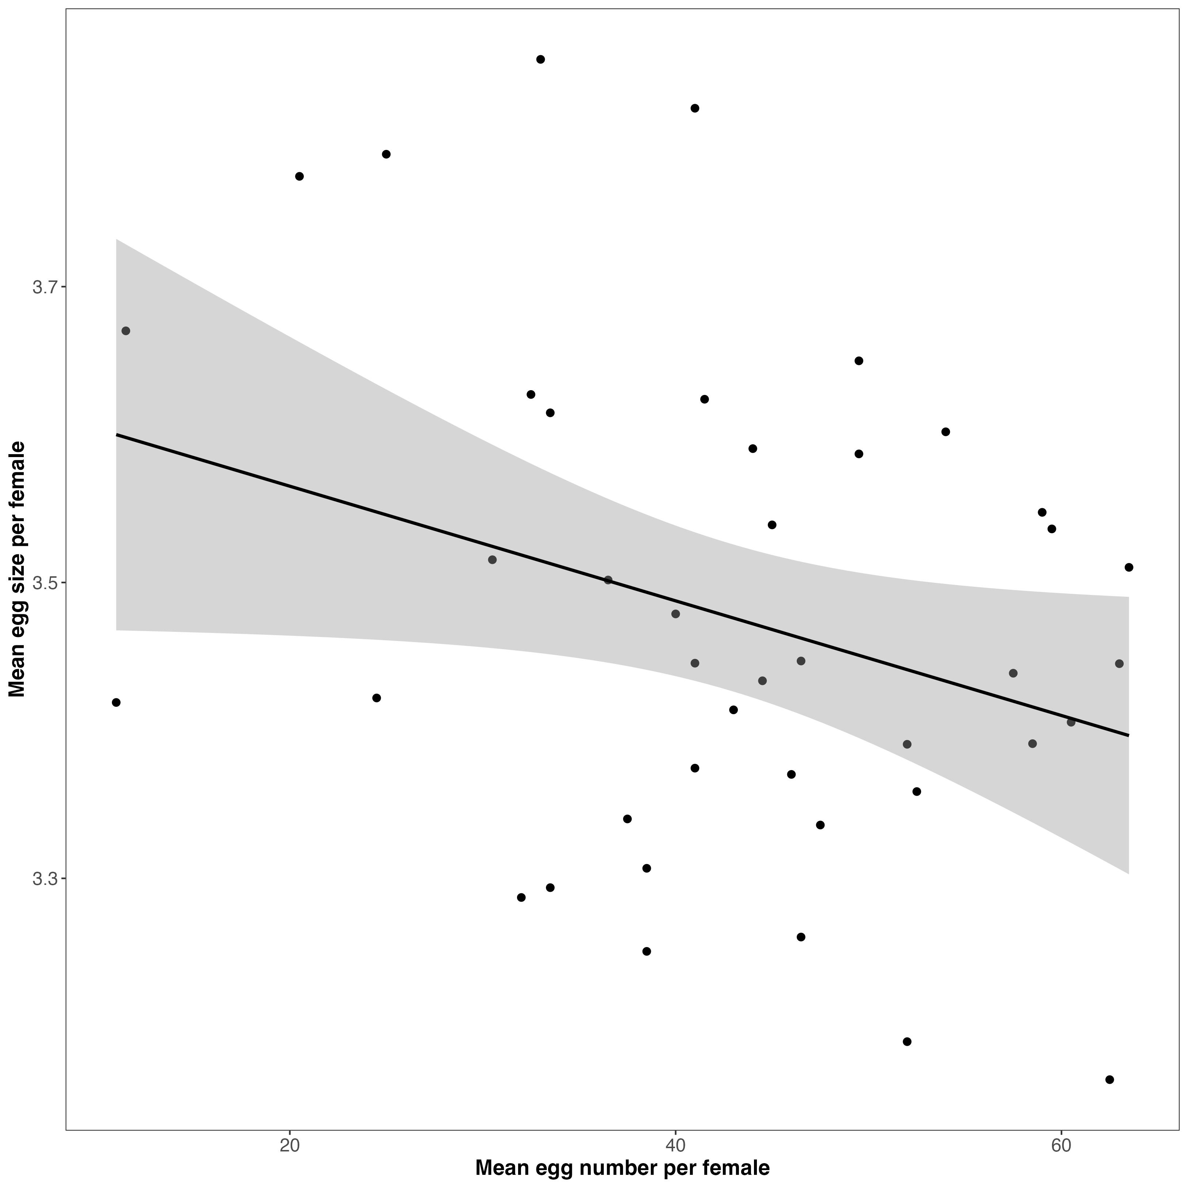
Figure 1: Relationship between mean egg number per female and mean egg size per female. Each point represents a single female (average of both clutches). The solid black line shows the posterior mean regression from the within–between mixed-effects model, and the shaded ribbon represents the 95% credible interval of the fitted relationship. The slope reflects the between-female effect ($β_{B}$ = -0.0039, 95% CrI [-0.0076, -0.0001]), indicating whether females that produce more eggs on average lay larger or smaller eggs. This relationship corresponds to the Pearson correlation calculated among female means ($r_{between}$ = -0.31, 95% CI [-0.55, -0.02]).

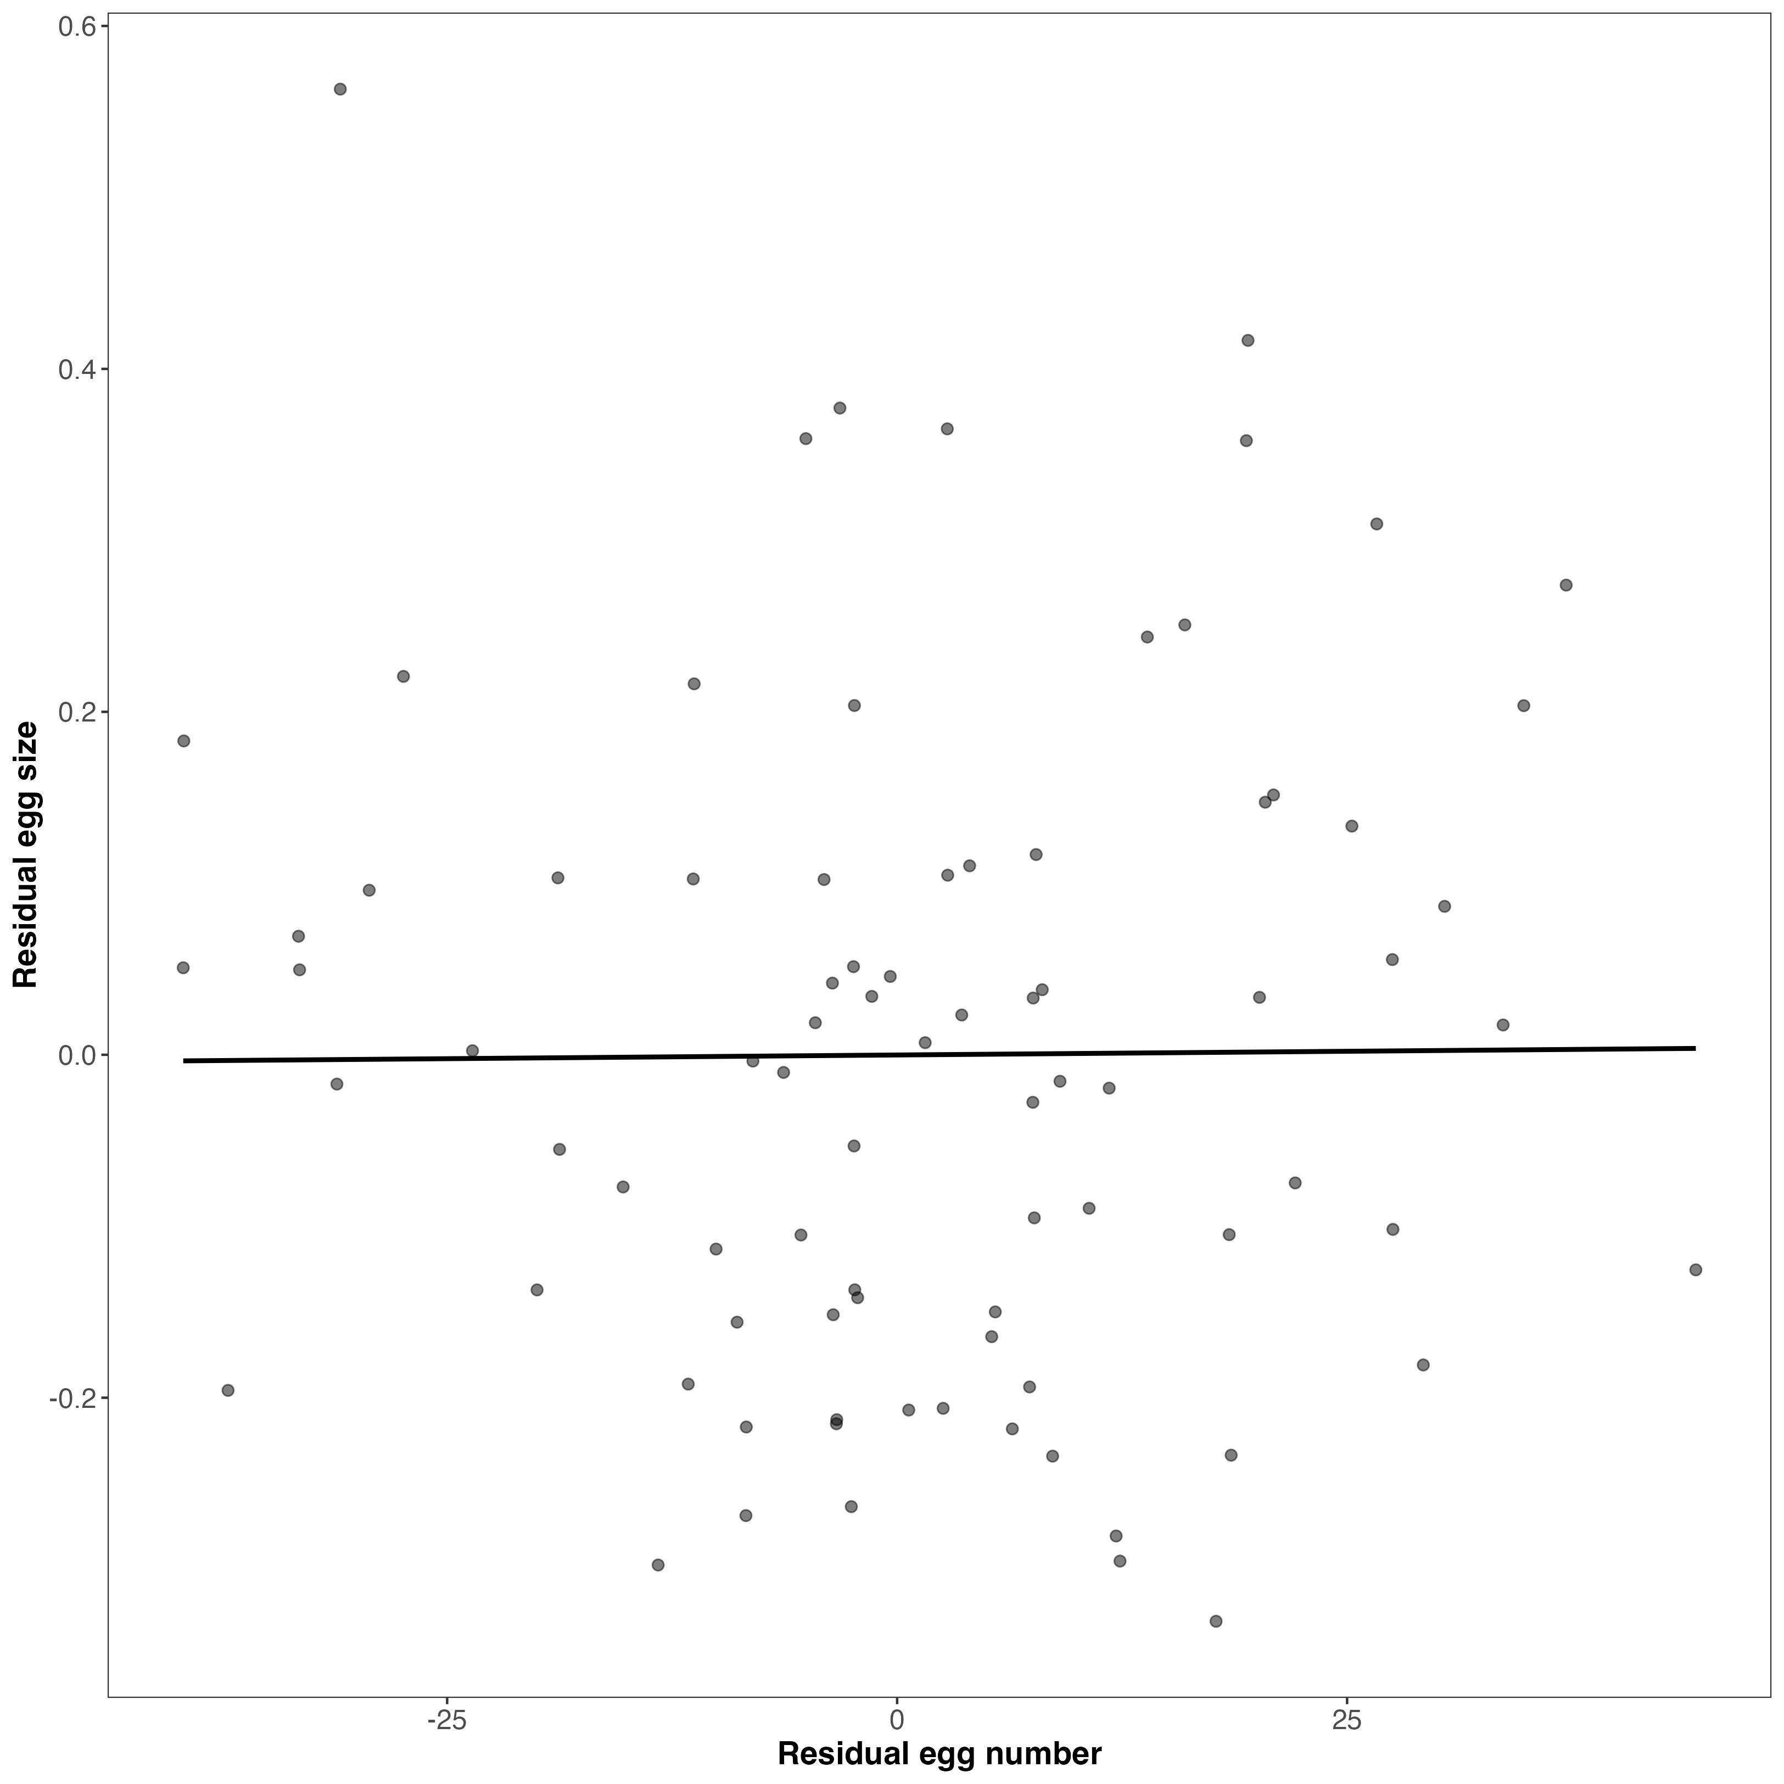
Figure 2: Within-female residual relationship between egg number and egg size from a multivariate Bayesian model. Points show posterior mean residuals for egg number and mean egg size for each clutch (n=82), extracted from a multivariate Gaussian brms model fitted with correlated residuals (set_rescor(TRUE)). Residuals therefore represent variation remaining after accounting for the random effects specified in ?@eq-residual, isolating within-female covariance between traits. The solid black line shows the linear regression fit to the residual values for visualization. The shallow slope is consistent with the posterior residual correlation estimated by the model (r = 0.0066 [-0.2018, 0.2299]), indicating little evidence for a within-female trade-off between egg number and egg size.

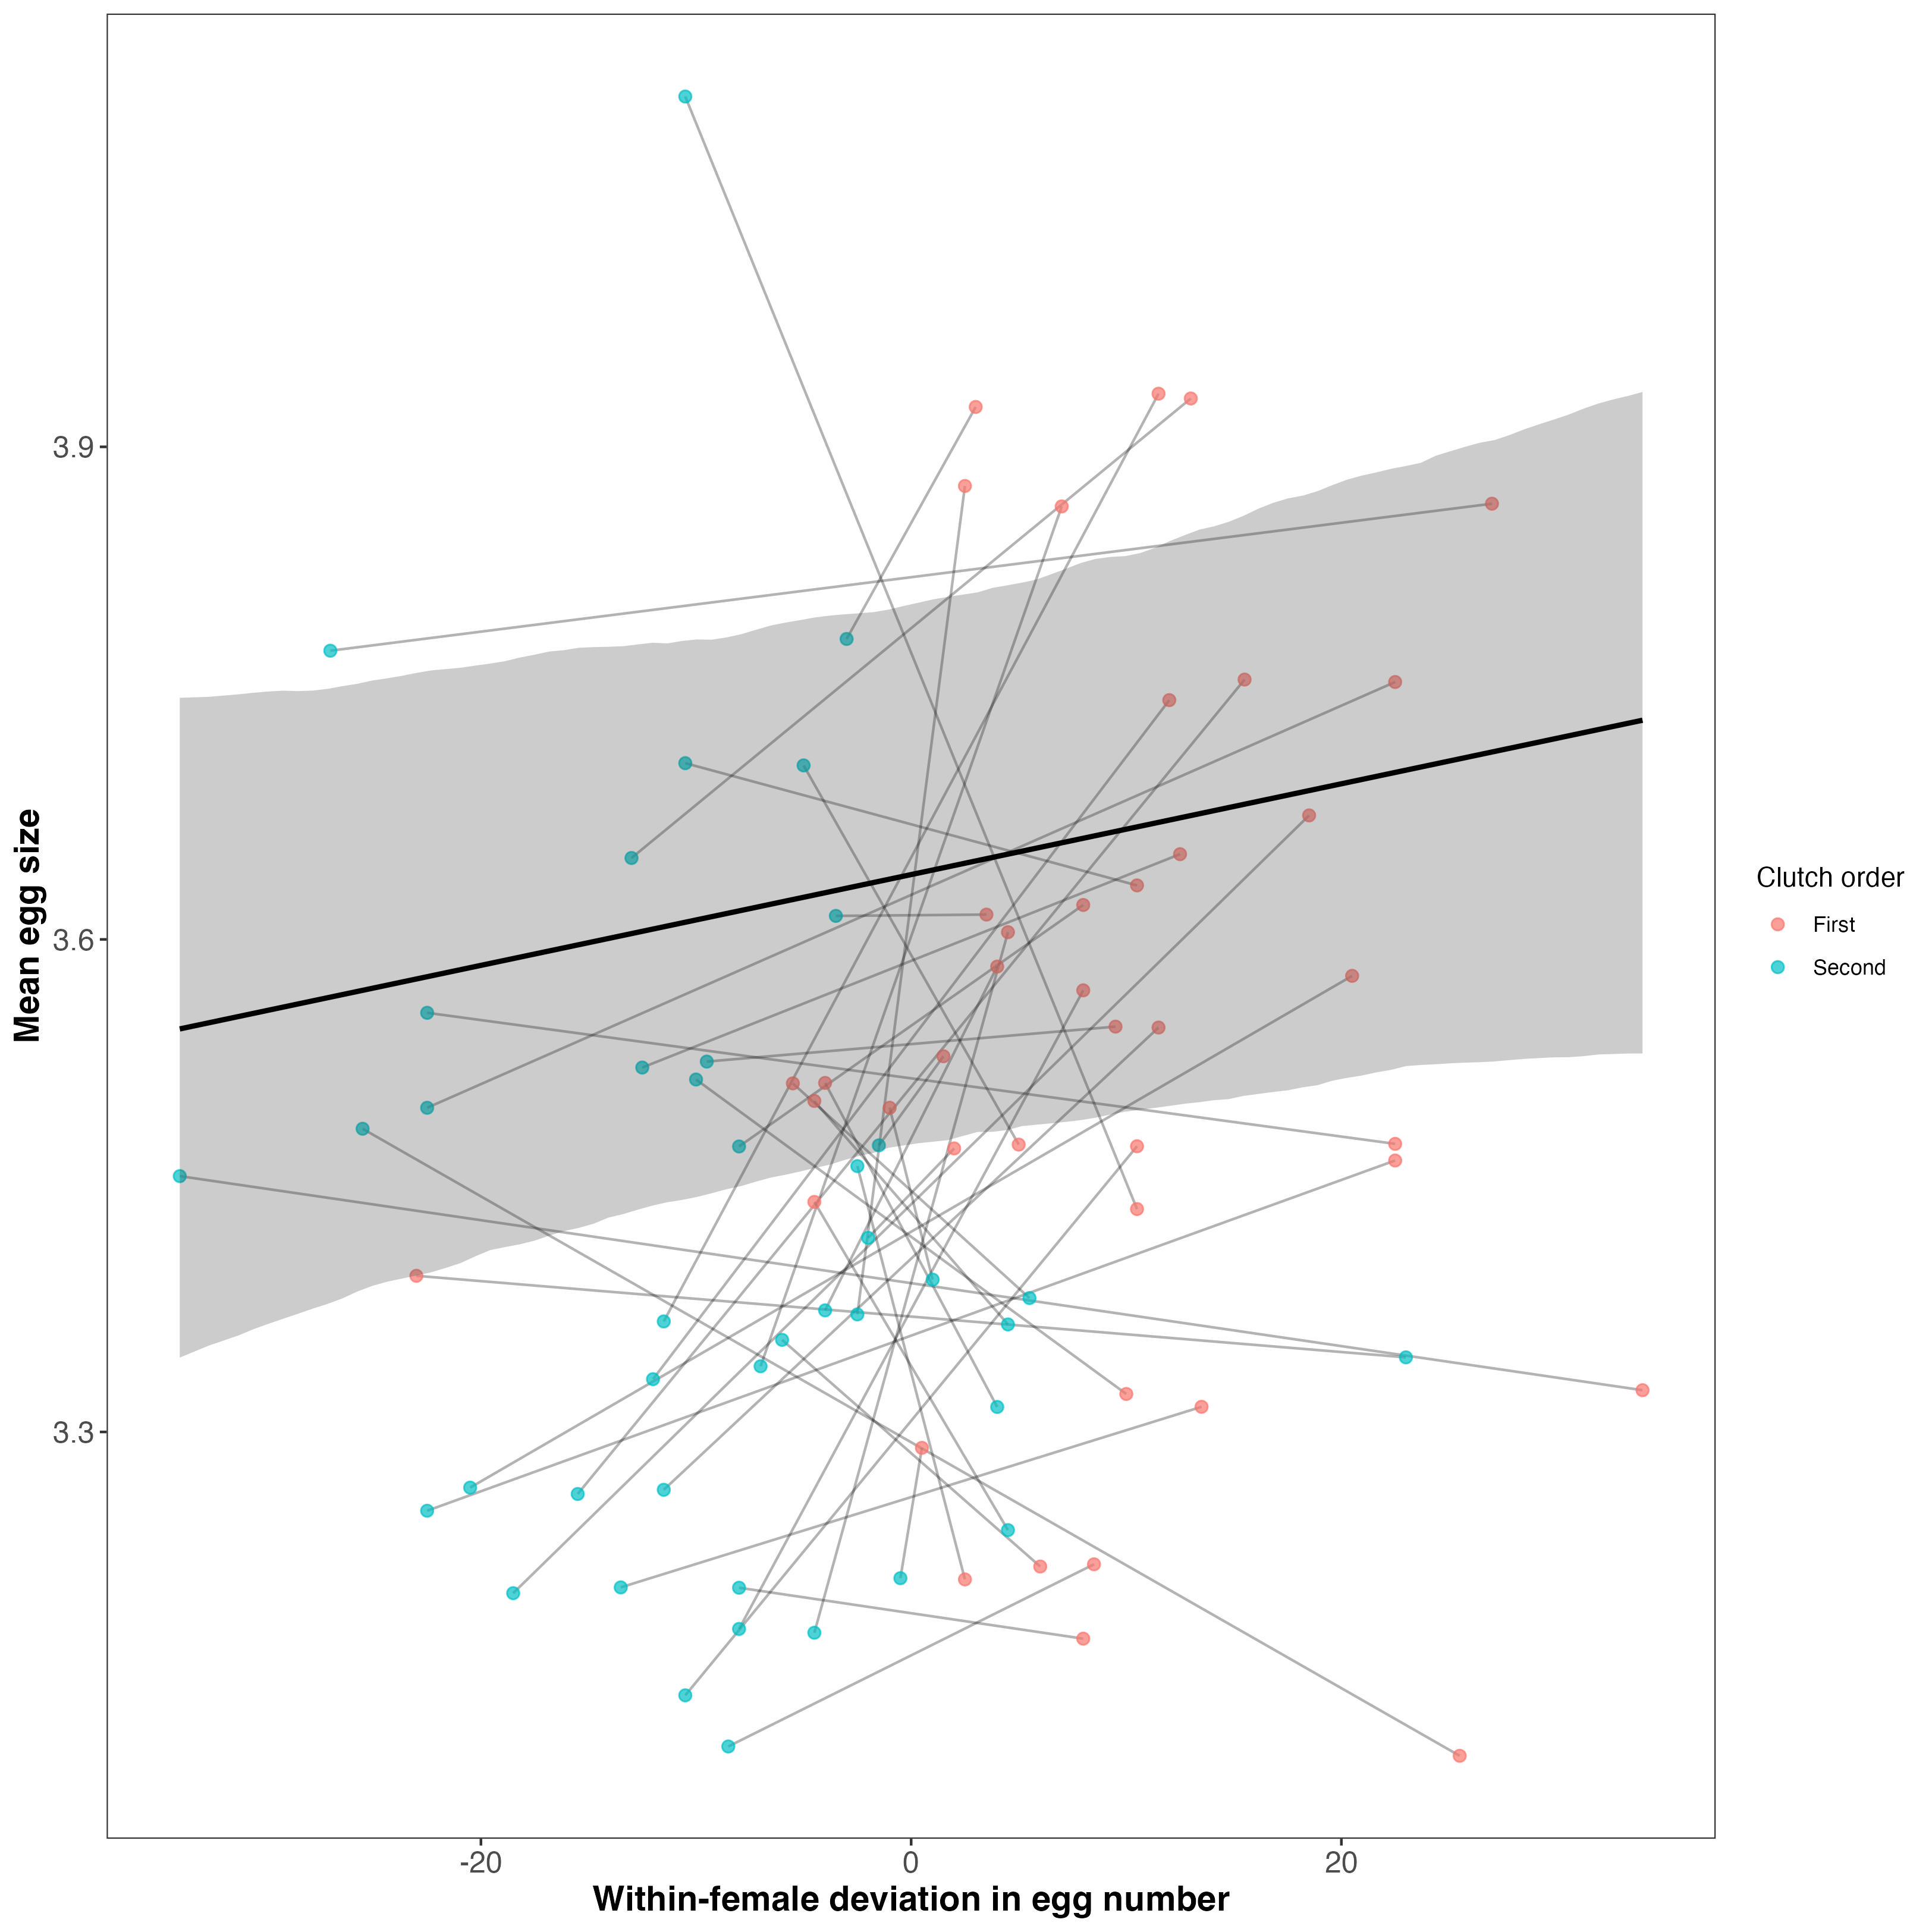
Figure 3: Mean egg size plotted against within-female deviation in egg number (clutch size minus each female’s mean). Points represent individual clutches, and thin gray lines connect successive clutches from the same female. The solid black line shows the posterior mean population-level effect of within-female egg-number deviation estimated from the mixed-effects model. The shaded ribbon represents the 95% credible interval of the posterior expected value (random effects excluded). Positive values on the x-axis indicate broods in which a female laid more eggs than her average, whereas negative values indicate broods with fewer eggs than her average. Note that second clutches (blue points) tend to negatively deviate from zero whereas first clutches (salmon points) tend to positively deviate from zero. The slope of the population-level line reflects the estimated within-female plastic response of egg size to changes in egg number 0.

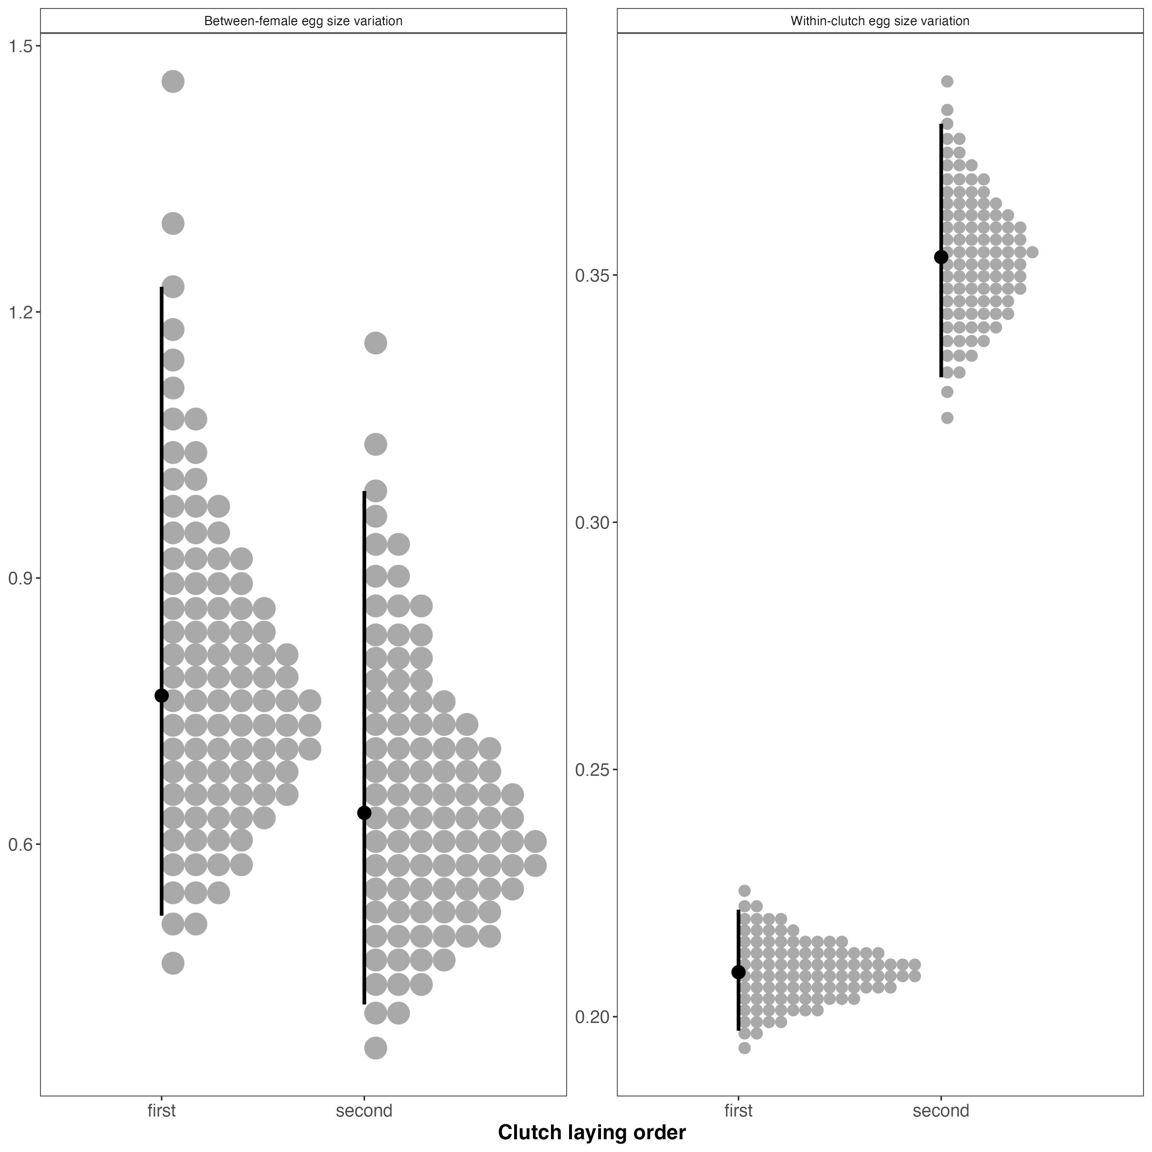
Figure 4: Clutch-specific variance components of egg size. (a) Between-female variance in egg size for first and second clutches, estimated from a hierarchical Bayesian model with clutch-specific female effects. (b) Within-clutch (egg-to-egg) variance for first and second clutches. Grey points represent posterior draws, black points indicate posterior medians, and vertical lines denote 95% credible intervals. Between-female variance did not differ clearly between clutches, whereas within-clutch variance was greater in second clutches.

